**Laboratory Experiment 3**

**EE348L**

**B. Madhavan**

**Revised by: Aaron Curry**

**Table of Contents**

**3 Experiment #3: OP-AMP THEORY & APPLICATIONS .....................................4**

3.1 Introduction: .............................................................................................................................. 4

3.2 Ideal Op-Amp Basics: ............................................................................................................... 4

3.3 Comparator:................................................................................................................................ 5

3.4 Feedback: .................................................................................................................................. 6

3.5 Op-Amp Characteristics:............................................................................................................ 8

3.5.1 Slew Rate: ..................................................................................................................... 8

3.5.2 Bandwidth: .................................................................................................................... 9

3.5.3 Offset Voltage:............................................................................................................... 9

3.6 Op-Amp Review......................................................................................................................... 9

3.7 Theory of Active Filters:............................................................................................................. 9

3.7.1 Second-Order low-pass filter: ..................................................................................... 11

3.7.2 Second-Order high-pass filter: .................................................................................... 14

37.3 Second-Order band-pass filter: ................................................................................... 16

3.8 References ............................................................................................................................... 21

3.9 Schematic diagram of a 741 op-amp: ...................................................................................... 21

3.10 LM741 SPICE Model…………...……………………………..……….………….…………22

3.11 Pre-lab exercise ........................................................................................................................ 25

3.12 Lab Exercises ........................................................................................................................... 29

**Table of Figures**

**Figure 3-1:** (a)VCVS conceptual representation of op-amp, (b) schematic representation.................. 5

**Figure 3-2:** Behavior of op-amp output voltage, assuming power supply = ±12V............................... 5

**Figure 3-3:** Basic op-amp comparator. ............................................................................................... 6

**Figure 3-4:** Op-amp without feedback………………………. ...........................................................….7

**Figure 3-5:** Op-amp with feedback: ................................................................................................... 7

**Figure 3-6:** Graph of an ideal low pass, band-pass, and high-pass filter output............................... 10

**Figure 3-7:** Graph of a typical low-pass, band-pass, and high-pass filter output. ………….............. 11

**Figure 3-8:** Low-pass Sallen and Key filter. ..................................................................................... 13

**Figure 3-9:** A graphed output of the low-pass Sallen and Key filter.................................................. 14

**Figure 3-10:** High-pass Sallen and Key filter. .................................................................................. 15

**Figure 3-11:** A graphed output of the high-pass Sallen and Key filter. ............................................ 16

**Figure 3-12:** Band-pass Sallen and Key filter.................................................................................. 17

**Figure 3-13:** A graphed output of the band-pass Sallen and Key filter. ........................................... 18

**Figure 3-14:** A schematic diagram of a cascade band pass filter. ................................................... 19

**Figure 3-15:** The typical response of a band-pass filter………………............................................. 20

**Figure 3-16:** Schematic diagram of a 741 op-amp............................................................................. 21

**Figure 3-17:** Figure for pre-lab problem 1......................................................................................... 25

**Figure 3-18:** Figure for pre-lab problem 2......................................................................................... 26

**Figure 3-19:** Figure for pre-lab problem 4 ......................................................................................... 26

**Figure 3-20:** Figure for pre-lab problem 5 .......................................................................................... 27

**Figure 3-21:** Figure for pre-lab problem 6 .......................................................................................... 28

**3 Experiment #3: Op-Amp Theory &** **Applications with Filters**

**3.1 Introduction:**

Operational amplifiers (op-amps for short) are incredibly useful devices that can be used to construct a multitude of electronic circuits. They are particularly attractive in both amplifier design and academic instruction because, more often than not, they can be treated as ideal amplifiers. An *ideal* op-amp has four basic characteristics; infinite gain, infinite bandwidth, infinite input impedance and zero output impedance. An ideal op-amp draws no power from the input due to the infinite input impedance. While the inherent low output impedance enables the op-amp to establish an output that is independent of the circuitry loading. While no amplifier is in fact ideal, the clarity and insight afforded by the assumption of ideal behavior makes the op-amp an attractive first step in designing any amplifier, even those that do not in fact exploit op-amps (e.g., other transistor amplifiers, which we will consider in later labs).

Broadly speaking, op-amps can be used two ways: 1) in the so-called *open-loop* mode, which is useful for comparators and triggers, and 2) with *feedback*, which is how nearly all amplifiers, filters and oscillators using op-amps are designed. In this lab you will use the op-amp to achieve more advanced filtering techniques. Initially, you will build a first order low and high pass filter. In this lab you will learn the basic concepts of a specific second order filter, called the Sallen and Key filter. There will be three types of filters presented; low pass, band pass and high pass. Second order filters are used because they produce better roll-off in the cut-off bands, as will be discussed later. The Sallen and Key filter is just one more of many applications of the op- amp.

**3.2 Ideal Op-Amp Basics:**

Conceptually, an ideal op-amp is nothing more than a voltage-controlled voltage source (VCVS) with infinite gain, infinite input impedance, and zero output impedance as shown in **Figure 3-1**. The op-amp is usually represented schematically as a triangle with two input terminals and one output terminal; the internal VCVS is implied. Note that in the representation in **Figure 3-1** when Rin= ∞, the input port is an open circuit; the implication is that the op-amp input impedance is so high that is does not load the circuitry driving the op-amp. If the input impedance of the op-amp were comparable to the output impedance of the driver circuitry, there would be a significant voltage division at the input port. This would not only reduce the op-amp output signal, but also cause the op-amp output to vary directly with the preceding stage output impedance. This is undesirable because the op-amp performance should depend entirely on its own characteristics, not those of external design components. Likewise, the ideal op-amp has no series output impedance, meaning that the op-amp can drive any load without voltage-divider attenuation. Further, notice that since the op-amp output port consists of a voltage source, there is no limit to the output current of an ideal op-amp.

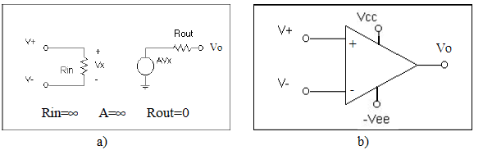

**Figure 3-1:** (a)VCVS conceptual representation of op-amp, (b) schematic representation.

At this point, you may be wondering about the practicality of a voltage source with infinite gain. Unless the input voltage is exactly zero, won’t the output voltage damage the electronics at the output port, or give a large undefined output voltage? This dilemma is resolved by the observation that the op-amp is a VCVS, an *active element*, necessitating an energy source to supply the gain. This source is the power supply, which is limited to a few volts (for op-amps in the lab, this may be ±12 V, on integrated circuits, perhaps as low as ±1V), constraining the output voltage to reside within the power supply boundaries. The “infinite” gain is true only for very small input signals, and for input voltages greater than a certain value (greater than 200 µV or less than 200 µV in **Figure 3-2**), the output simply clips at one of the supply rails. The input level at which the output clips is determined by the open-loop gain of the operational amplifier. This type of operation is used to exploit the op-amp as a comparator or trigger.



**Figure 3-2:** Behavior of op-amp output voltage, assuming power supply = ±12V.

**3.3 Comparator:**

A comparator does exactly what its name implies. It compares two signals, and then produces an output based on the comparison. Making a comparator with an op-amp is really easy. As indicated in Figure 3.3, connect the input into one terminal (positive) and a reference voltage into the other terminal (negative). The reference voltage is achieved with the voltage divider shown. The op-amp output will saturate at either the positive (Vcc) or negative rail (Vee), depending on whether the input is greater than or less than the reference voltage. The exact opposite would occur if the inputs were switched to the opposite input terminal of the op-amp. The comparator can be thought to have a digital output; its output is either “high” or “low” depending on the comparison executed at the input. So, if your input happens to be a sinusoid, then the output will be a square wave of the same period.

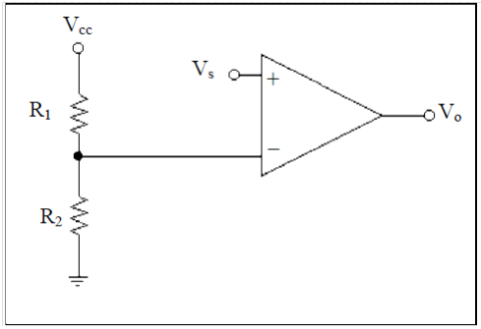

**Figure 3-3:** Basic op-amp comparator.

While the principle is simple, there is a problem with this circuit, which a Schmitt trigger will eliminate. The problem is noise, which can cause the op-amp output to switch incorrectly. Consider a small sinusoid input that has just gone positive relative to the reference, and imagine that the sinusoid is corrupted by noise with power relative to the signal power. This noise could subtract from the input right after the positive transition, causing the output to erroneously dip negative until the sine wave becomes more positive and corrects the output. If this comparator were used as a simple clock circuit, then clearly these glitches in the output waveform would cause considerable errors in timing.

**3.4 Feedback:**

For the situation of Fig. 3.2, it is clear that the op-amp acts linearly only for inputs less than ±200µV! This is so small compared to the supply that it seems insignificant. It would appear that to be practical, one might just as well ignore the linear region and model the op-amp as |Vo|=12V (with the polarity sign of Vo being determined by the sign of Vs). In fact, with the exception of comparator/trigger-type functions, the linear region *is the only* region in which the op-amp is used! This is achieved by utilizing feedback, in which a portion of the op-amp output is fed back to the inverting terminal. The op-amp will produce an output signal that varies proportional to the input signal by *forcing* the two input terminals to be at nearly the same potential. Consider the situation depicted in **Figure 3-4** and **Figure 3-5**:

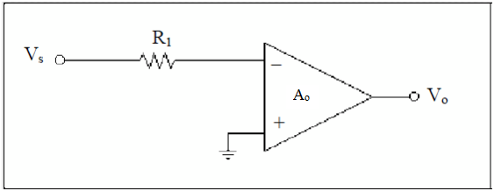

**Figure 3-4:** Op-amp without feedback.

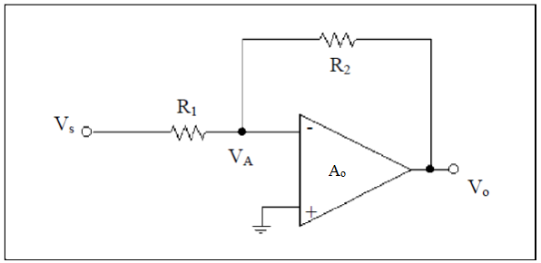

**Figure 3-5:** Op-amp with feedback.

Without feedback, the op-amp output lies at the supply rail. However, when resistor R2 is connected, the following Kirchhoff equations can be written:

 (3.2)

 (3.3)

resulting in

 (3.4)

for  (3.5)

Suppose now that vs is a sine wave with amplitude 100 mV, Ao=60e3, R1=1k, R2=5k. The amplitude of the source voltage is *much* more than the permissible 200 µV range shown before. The feedback path provided by the R1-R2 voltage divider causes the input differential voltage to be very close to zero and the output amplitude to be 500 mV. If we solve for VA, we can see that the input to the op-amp is clearly within the +/- 200 µV range:

 (3.6)

**3.5 Op-Amp Characteristics:**

So far, a very simple model of the op-amp has been explored. In general, this is quite suitable for many designs, and certainly adequate for a first-pass at almost any design. However, real-life designs often have stringent specifications that force one to consider complicated non-ideal op- amps. Because of this, it is worth exploring the sources of some common non-idealities to see what can be done to mitigate their effects.

**3.5.1 Slew Rate:**

The term slew rate refers to how fast the output can swing without becoming distorted. Consider the circuit discussed in Fig. 3.6(b) with a sinusoidal input. Recall that the slope of a sinusoid is directly proportional to its frequency and amplitude; this means that as one increases the amplitude and/or frequency of the input sinusoid (and/or the closed-loop gain of the op-amp), the output voltage must swing at a faster rate.

It turns out that the input stage of an op-amp is a transconductor, which ideally converts the input signal voltage into a proportional signal current. However, in reality, as the input voltage swing gets too large, the signal current available from the transconductor approaches an asymptotic limit, which is a non-linear phenomenon. It follows that even if the signal current is run through a *perfect* current-to-voltage converter to produce the final output voltage, the op-amp output voltage is necessarily *not perfectly proportional* to the input voltage, and will appear distorted.

Furthermore, the output of any op-amp is capacitive to some degree, which complicates matters still more. Recalling that the I-V relation of a capacitor is:

 (3.7)

It is clear that the rate at which the output voltage can swing is diminished for large output capacitance and small charging current. The charging current is limited by how much DC current the input stage is able to provide the output stage, which ties directly to the limiting signal current phenomenon discussed earlier.

While the input voltage may increase very rapidly, the output climbs a bit slower; once the input sinusoid has reached its peak and beings to decrease, the output naturally wants to reach its peak, though the input is directing it to change direction and decrease. Simply put, slew rate is electrical momentum – at low speeds, it is easy to change the direction of a moving object, but the faster that object moves, the longer the response time for the object to pursue the direction dictated by the driving force.

**3.5.2 Bandwidth:**

Like slew rate, the finite bandwidth of an op-amp limits the performance at high frequencies. However, whereas slew rate non-linearly *distorts* the shape of a given output frequency (i.e., alters its shape from that of the input), the bandwidth of the op-amp causes the output amplitude to decrease with increasing frequency. The bandwidth also causes the output to incur some phase shift relative to the input, which is a linear effect. The culprit is typically compensation capacitance internal to the op-amp. Compensation capacitance is used to guarantee a one-pole response, and as we will see later, guarantee a stable response when feedback is applied. To account for this effect, one may replace the gain “A” with a frequency-dependent gain, A/(1 + s/p). One final note is that the finite bandwidth can cause *linear distortion* if the input waveform consists of more than one sinusoid, each experiencing a different phase shift and amplitude reduction due to the one-pole response. While the response is still linear, the output waveform may look completely different from the input.

**3.5.3 Offset Voltage:**

We have assumed that the op-amp is totally balanced inside, so when both input terminals are at the same potential, the output voltage should be precisely zero. However, in reality, the circuitry looking into both terminals is not precisely matched (due both to asymmetry in the input stage of the op-amp as well as processing imperfections in manufacturing the op-amp), and this results in an innate imbalance leading to an offset voltage. The offset voltage of an op-amp is defined as the input voltage differential required to adjust the output voltage to zero. Note that as long as this input voltage lies within the range necessary to cause linear VCVS gain, one can relate the input offset voltage to the output voltage resulting from zero input by the gain “Ao” of the op-amp.

**3.6 Op-Amp Review:**

The op-amp is one of the fundamental building blocks in most analog circuits. From an ideal standpoint, it is very easy to implement and analyze. The ideal op-amp has four basic features that make it irreplaceable in circuit design. These are: infinite input impedance, zero output impedance, infinite bandwidth, and infinite gain. This lab teaches you the basics behind using the op-amp as a linear device to achieve gain and filtering. The non-ideal attributes of finite slew- rate, finite bandwidth, and non-zero offset voltage, limit the performance and the validity of the ideal model. Thus, circuit designers go to great lengths to minimize these non-idealities.

**3.7 Theory of Active Filters:**

A filter is a circuit that lets certain frequencies pass and blocks other frequencies. There are two different types of filters: passive and active. Passive filters are completely comprised of passive elements; namely resistors, capacitors and/or inductors. Active filters use active devices, i.e. an op-amp, to aid in the filtering.

Active filters have the following advantages over passive filters.

-Gain and frequency adjustment and tuning.

-No inductors (reduces cost and size).

-No loading effects.

Some disadvantages of active filters.

-Bandwidth limitations

-Fabrication tolerances

-Can only respond to a specific range of signal magnitudes.

Filters can be classified as; low-pass, high-pass, band-pass, notch, or all pass circuit. These circuits are all used for different purposes, but this lab will focus on the design of low pass, band pass and high pass Sallen and Key Filters. Figure 3-6 shows the performance of an ideal low-pass, band-pass, and high pass circuit. In the lab exercises you will look a first order low pass and a first order high pass filter. Then you will design a second order Sallen and Key band-pass filter. Sallen and Key filters implement a second order topology that results in better performance than first-order filters. To be sure, the Sallen and Key topologies are also more complicated.

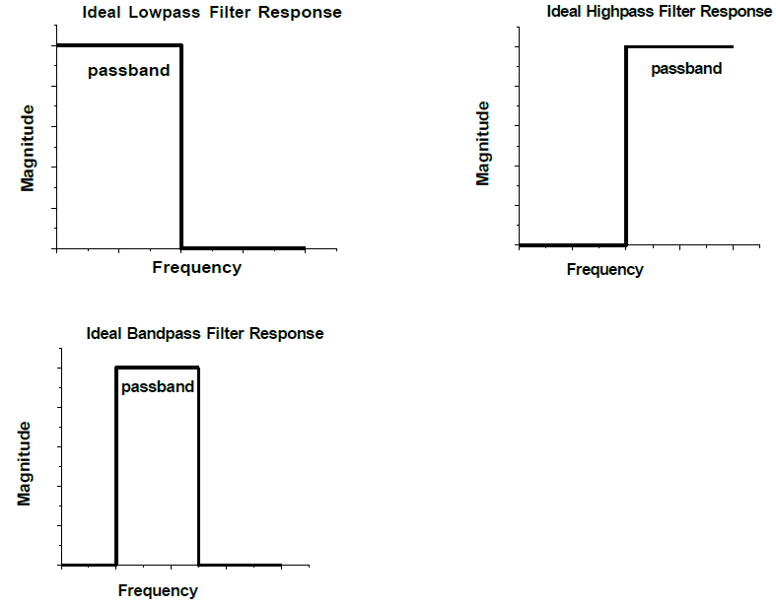

**Figure 3-6:** Graph of an *ideal* low pass, band-pass, and high-pass filter output.

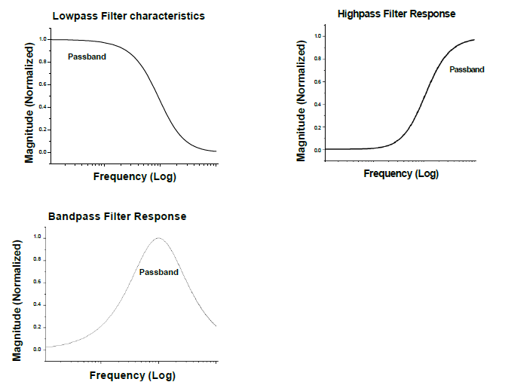

**Figure 3-7:** Graph of a *typical* low-pass, band-pass, and high-pass filter output.

Unfortunately almost nothing in circuit design is ideal. Figure 3-7 shows the typical behavior of a low pass, band-pass, and high-pass filter. (Actually, in reality there is no such thing as a high-pass filter. Every high-pass filter has roll off at some higher frequency and becomes a band-pass filter.) The first difference between ideal and real filters that you can observe is roll-off. Real filters do not have the extreme cut-off between the pass-band and reject-band transitions. One might question how the performance of different filters is compared. This is why key criterion like the 3dB frequencies have been developed. The 3dB frequency is defined as the frequency where the magnitude of the gain has dropped by a factor of the square root of 2 (0.707 = approximately 70%).

The limitation of the first order circuits is the roll-off in the cut-off band. First order low or high pass filters experience a –20db/decade roll-off in the cut-off regions. A –20dB/decade roll-off is insufficient for some applications, so a higher order filter is used. A second order filter generates a -40dB/decade. In general, the higher the order of the circuit, the better the roll-off between the stop and pass bands. These results can be best visualized using Bode Plots.

**3.7.1 Second-Order low-pass filter:**

A general transfer function of a second order low-pass filter is

 (3.8)

where H(0) is the dc gain, ωo is the undamped self-resonant/natural frequency, and Q is the quality factor. The alternate form of equation (3.8) is

 (3.9)

As can be seen from comparing equations (3.8) and (3.9),

 (3.10)

It is important to note that the damping factor is inversely proportionate to the quality factor. Therefore, a high-quality system has low-damping, and vice versa. This lab will use the form with the quality factor Q instead of the damping factor ξ. However, one can use equation (3.10) to go back and forth between Q and ξ. The poles of the transfer function from equation (3.8) are

 (3.11)

Figure 3-8 shows a schematic diagram of a low-pass Sallen and Key filter.

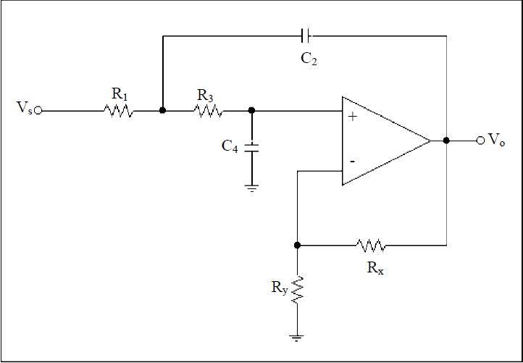

**Figure 3-8:** Low-pass Sallen and Key filter.

The gain of the circuit, A, is controlled by the feedback associated with the op-amp, namely Rx

and Ry. The transfer function, undamped natural frequency (ωo), and Quality factor (Q) are given by:

 (3.12)

 (3.13)

 (3.14)

 (3.15)

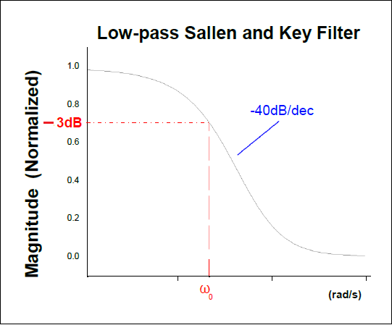

**Figure 3-9:** A graphed output of the low pass Sallen and Key filter.

**3.7.2 Second-Order high-pass filter:**

A general transfer function of a second order high-pass filter is

 (3.16)

where H(∞) is the high frequency gain, ωo is the undamped natural frequency, and Q is the quality factor. Again, the damping factor, ξ, is related to Q through equation (3.10). The poles of this transfer function are the same as in equation (3.11). **Figure 3-10** shows a schematic diagram of a high-pass Sallen and Key filter, while **Figure 3-11** shows a typical output of the circuit in **Figure 3-10**. Note that **Figure 3-10** is obtained from **Figure 3-8** by replacing components R1,R2 in **Figure 3-8** with C1,C3 and C2,C4 in **Figure 3-8** with R2,R4. Note the symmetry between two figures (R’s and C’s are swapped).

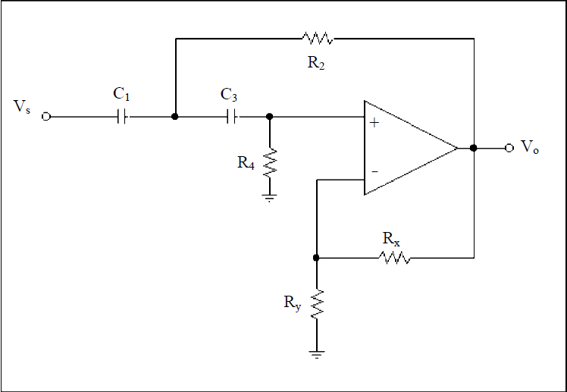

**Figure 3-10:** High-pass Sallen and Key filter.

The gain of the circuit, A, is controlled by the feedback associated with the op-amp, namely Rx

and Ry. The transfer function, pole frequency (ωo), and Quality factor (Q) are given by

 (3.17)

 (3.18)

 (3.19)

 (3.20)

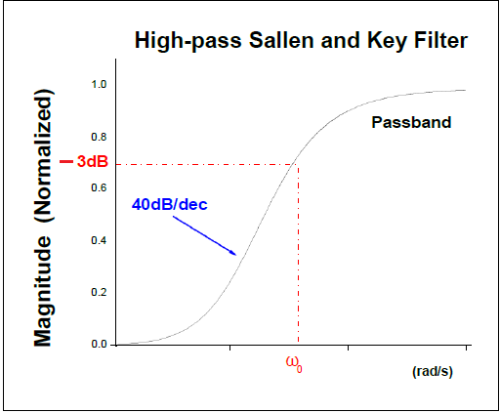

**Figure 3-11:** A graphed output of the Sallen and Key high-pass filter.

**3.7.3 Second-Order band-pass filter:**

A general transfer function of a second order band-pass filter is

 (3.21)

where H(jωo) is the frequency gain at ωo, ωo is the center frequency, and Q is the quality factor. Again, the damping factor, ξ, is related to Q through equation (3.10). The poles of this transfer function are the same as in equation (3.11). **Figure 3-12** shows a schematic diagram of a band-pass Sallen and Key filter, while **Figure 3-13** shows a typical output of the circuit in **Figure 3-12**.

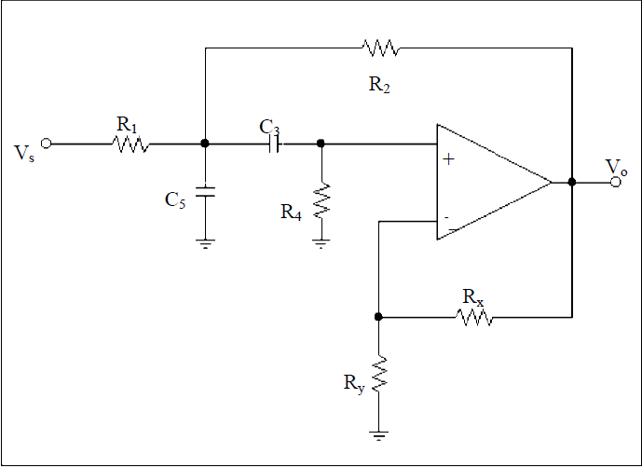

**Figure 3-12:** Band-pass Sallen and Key filter.

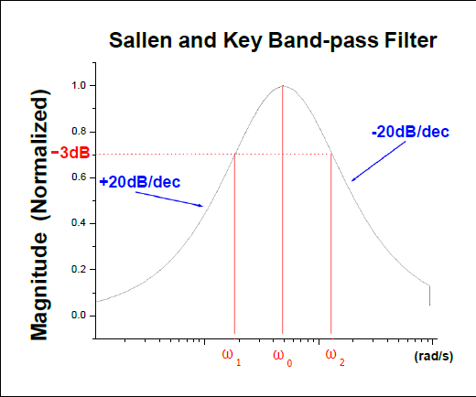

**Figure 3-13:** A graphed output of the band-pass Sallen and Key filter.

The gain of the circuit, A, is controlled by the feedback associated with the op-amp, namely Rx

and Ry. The transfer function, center frequency (ωo), and Quality factor (Q) are given by:

 (3.22)

 (3.23)

 (3.24)

 (3.25)

 (3.26)

Unlike the Sallen and Key high and Low-pass filters, the band-pass rolls off at –20dB/decade. The reason for the difference is that the pass-band filter has to reject two bands of signals. One pole is used to get a 20bB/decade roll-up to the center frequency, and the other pole is used to get a –20dB/decade roll-off after the center frequency.

Another way to realize a band-pass is to cascade a low and high-pass filter. **Figure 3-14** shows a schematic diagram of a high and low-pass filter used to get a band-pass effect. A typical response of this circuit is very similar to the Sallen and Key filter, but the overall circuit is large and requires two op-amps. There are limitations to this cascade approach. Drawbacks include limitation on Q, power consumption, and others.

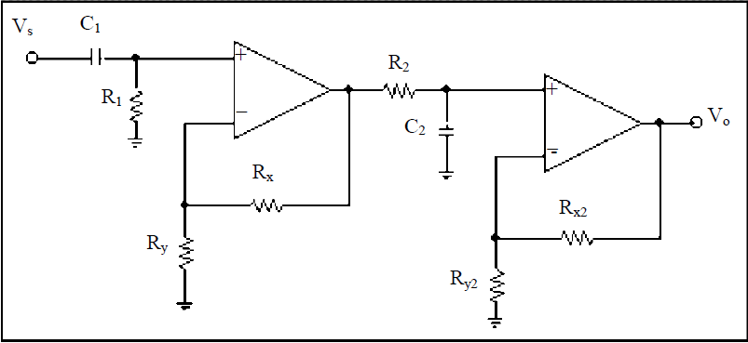

**Figure 3-14:** A schematic diagram of a cascade band pass filter.

It is important to note that another expression for quality Q and center frequency fc are described by:

 (3.27)

 (3.28)

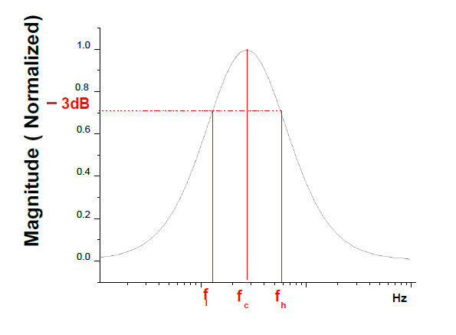

**Figure 3-15**: The typical response of a band-pass filter.

**3.8 References**

[1] Roland E. Thomas & Albert J. Rosa. *The Analysis and Design of Linear Circuits*, chapter 4.

Prentice-Hall Inc., Englewood Cliffs, New Jersey, 1994.

[2] Donald A. Neamen. *Electronic Circuit Analysis and Design*, chapters 9 & 13. Irwin, Chicago,

1996.

[3] David Johns & Ken Martin. *Analog integrated Circuit Design*, chapters 5 & 6. John Wiley & Sons, Inc., New York, 1997.

[4] Paul R. Gray & Robert G. Meyer. *Analysis and Design of Analog Integrated Circuits*, chapter 6.

John Wiley & Sons, Inc., New York, 1993.

[5] John Choma, Jr. *EE348 lecture notes*. University of Southern California. Spring 2001.

[6] P. Allen, B Blalock, & S. Milam. *The Circuits and Filters Handbook*, Chapter 75. CRC Press

Inc., 1995

**3.9 Schematic diagram of a 741 op-amp:**

In this lab we will be using LM741 op-amps for our circuits. **Figure 3-15** shows the pin-out of the LM741 devices.

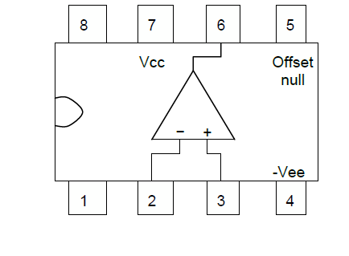

**Figure 3-16:** Schematic diagram of a 741 op-amp.

**3.10 LM741 SPICE Model**

The LM741 SPICE model is below. It can be copied and pasted into your netlist. Or, you can create a file called <name>.lib with this in it, and then reference it at the beginning of your netlist with the .inc statement:

.inc “<file path>”

*//////////////////////////////////////////////////////////////////////

* (C) National Semiconductor, Inc.

* Models developed and under copyright by:

* National Semiconductor, Inc.

*/////////////////////////////////////////////////////////////////////

* Legal Notice: This material is intended for free software support.

* The file may be copied, and distributed; however, reselling the

* material is illegal

*////////////////////////////////////////////////////////////////////

* For ordering or technical information on these models, contact:

* National Semiconductor's Customer Response Center

* 7:00 A.M.--7:00 P.M. U.S. Central Time

* (800) 272-9959

* For Applications support, contact the Internet address:

* amps-apps@galaxy.nsc.com

*//////////////////////////////////////////////////////////

*LM741 OPERATIONAL AMPLIFIER MACRO-MODEL

*//////////////////////////////////////////////////////////

*

* connections: non-inverting input

* | inverting input

* | | positive power supply

* | | | negative power supply

* | | | | output

* | | | | |

* | | | | |

.SUBCKT LM741 1 2 99 50 28

*

*Features:

*Improved performance over industry standards

*Plug-in replacement for LM709,LM201,MC1439,748

*Input and output overload protection

*

****************INPUT STAGE**************

*

IOS 2 1 20N

*^Input offset current

R1 1 3 250K

R2 3 2 250K

I1 4 50 100U

R3 5 99 517

R4 6 99 517

Q1 5 2 4 QX

Q2 6 7 4 QX

*Fp2=2.55 MHz

C4 5 6 60.3614P

*

***********COMMON MODE EFFECT***********

*

I2 99 50 1.6MA

*^Quiescent supply current

EOS 7 1 POLY(1) 16 49 1E-3 1

*Input offset voltage.^

R8 99 49 40K

R9 49 50 40K

*

*********OUTPUT VOLTAGE LIMITING********

V2 99 8 1.63

D1 9 8 DX

D2 10 9 DX

V3 10 50 1.63

*

**************SECOND STAGE**************

*

EH 99 98 99 49 1

G1 98 9 5 6 2.1E-3

*Fp1=5 Hz

R5 98 9 95.493MEG

C3 98 9 333.33P

*

***************POLE STAGE***************

*

*Fp=30 MHz

G3 98 15 9 49 1E-6

R12 98 15 1MEG

C5 98 15 5.3052E-15

*

*********COMMON-MODE ZERO STAGE*********

*

*Fpcm=300 Hz

G4 98 16 3 49 3.1623E-8

L2 98 17 530.5M

R13 17 16 1K

*

**************OUTPUT STAGE**************

*

F6 50 99 POLY(1) V6 450U 1

E1 99 23 99 15 1

R16 24 23 25

D5 26 24 DX

V6 26 22 0.65V

R17 23 25 25

D6 25 27 DX

V7 22 27 0.65V

V5 22 21 0.18V

D4 21 15 DX

V4 20 22 0.18V

D3 15 20 DX

L3 22 28 100P

RL3 22 28 100K

*

***************MODELS USED**************

*

.MODEL DX D(IS=1E-15)

.MODEL QX NPN(BF=625)

*

.ENDS

**3.11 Pre-lab exercise**

For all SPICE simulations, use the LM741 model deck (section 3.10) for op-amps.

1. Refer to the amplifier in **Figure 3-17**.
2. Assuming an ideal op-amp, compute the transfer function of the amplifier.
3. Verify your results in SPICE. Use the following circuit values: Vcc=+12V, Vee=-12V, R1=1kΩ, R2=5kΩ, and Vs is a sine wave with a frequency of 10 kHz, amplitude of 10mV and a delay of 10us. Does your output look like you expected?
4. Which of the second-order phenomena is occurring from section 3.5?

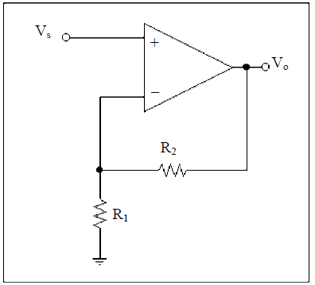

**Figure 3-17**:Figure for pre-lab problem 1.

1. Refer to the amplifier in **Figure 3-18**.
2. Assuming an ideal op-amp, compute the transfer function of the amplifier.
3. Verify your results in HSPICE. Use the following circuit values: Vcc=+12V, Vee=-12V, R1=2kΩ, R2=4kΩ, and Vs is a sine wave with a frequency of 10 kHz and amplitude of 1mV.
4. Which of the second-order phenomena is occurring from section 3.5?

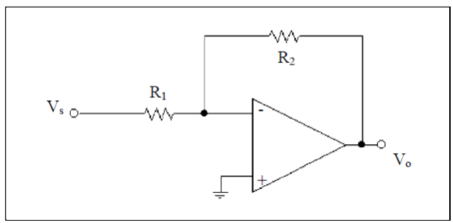

**Figure 3-18**:Figure for pre-lab problem 2.

1. What is the main difference in the gain of the op-amp configuration in **Figure 3-17** compared to the amplifier in **Figure 3-18**?
2. Refer to the topology featured in **Figure 3-19**.
3. Derive the transfer function of this circuit.
4. What is the purpose of this circuit?
5. Why is it a good one? (Hint: Consider the input and output properties of this circuit. What is Rin? What is Rout? Is there a limit to the amount of current this circuit can source?)

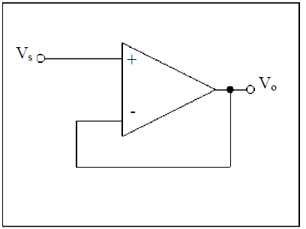

**Figure 3-19**:Figure for pre-lab problem 4.

1. Refer to the circuit in **Figure 3-20**.
2. Derive the transfer function of this circuit.
3. What type of filter is this? (Include the order.)
4. What is the pass-band gain?
5. What is the -3dB frequency?
6. Verify your results in Spice with an “.AC” simulation using R1=500Ω, R2=2.5k, C=0.01µF, and a source with a 1V magnitude. Do the Spice results agree with what you derived? If not, why?

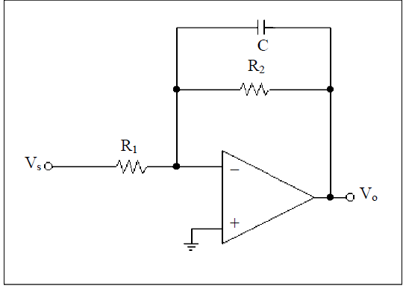

**Figure 3-20** Figure for pre-lab problem 5.

1. Repeat the procedure in problem #5 for the circuit in **Figure 3-21**. NOTE: The spice simulation for this problem should give you an idea why all high-pass filters are really band-pass filters!

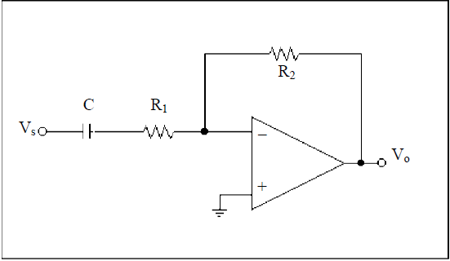

**Figure 3-21**. Figure for pre-lab problem 6.

1. You are to design a second order Sallen and Key band-pass filter (**Figure 3-12**) using the information in the section on active filters (Section 3.7.3). The band-pass filter should have a center frequency of 3kHz, a gain of 2 and Q=2. Verify your design using SPICE.

You may choose any R and C values you wish and use any methods that were presented here or that you have learned in class to complete this pre-lab.

**Hint:** Choose values of R and C that make your life easier by simplifying the equations. For instance, letting C3=C5 allows all the C’s to drop out in all of the equations.

**It can be shown that R1/R2 must be greater than 2.33 in order for the filter to work with the given specifications.**

You will need to turn in a schematic diagram, all parameter calculations, and Spice simulations to prove your design works.

1. Are there any differences between your calculations and your Spice results? If there are, try to explain why or give any deductive reasoning or insight. Tune or change any parameters to get within ±10% of the specifications.
   1. **Lab Exercises**

* Make sure you use enough data points to get good plots (at least 10-15).
* If a lab exercise asks you to compare your results with your pre-lab, include your pre-lab result in your lab report! Simply stating they are the same is not good enough!
* Submit plots relevant to reach question in your lab report.
* Remember that an amplitude of 50mV corresponds to a Vpp of 100mV.

1. Build the comparator in **Figure 3-3**. Apply a sin wave input with a frequency of 1 kHz and amplitude of 2.5V. Instead of using a resistive divider for the negative terminal, connect it to a voltage source and set it to 0V. Graph Vo vs. time and Vs vs. time. Is your Vo a square wave? What should happen as you adjust the voltage at the negative terminal? Adjust the voltage and verify.
2. For both circuits in questions #1 and #2 of the Pre-lab, build the circuit and compare the gain you measure to the one you calculated. Sketch the input and output waveforms. Is the measured gain equivalent to the one you calculated? Why or Why not?
3. Build the circuit in **Figure 3-19**. Use a sinusoidal input and vary the amplitude. What is this circuit? Does the hand analysis that you did in the Pre-lab agree with the data you gathered?
4. Build the circuit in **Figure 3-20**. Use values close to those specified in Pre-lab number 5 and state what values you used. Based on pre-lab number 5, what type of filter should this be? Use a frequency generator to verify. Is it what you expected? Now, calculate the pass-band gain and -3dB frequency using the values in your circuit. Start taking measurements at two decades before the -3dB frequency and stop at two decades after. Measure the values for the pass-band gain and -3dB frequency. Do your results agree with the transfer function you derived in part 5 of the pre-lab? How do your measured values compare to your calculated values? Plot your results in excel (or an equivalent). Be sure to plot the transfer function gain. This is the output amplitude **divided by the input amplitude**. Do not just plot the output amplitude.
5. Repeat lab exercise 4 for the op-amp configuration in **Figure 3-21**.
6. Build the second-order active band-pass filter that you designed in pre-lab question 7. Sweep the frequency of a 100mV sine wave source and verify that you filter meets the specifications by recording the magnitude of the output. A good strategy would be to collect two data points every 1kHz, then go back and collect data points at smaller intervals at sudden transition points. This will save time and give you enough data to accurately plot your results (using excel, or any other equivalent program) for your report. Did your results in lab match your Spice simulations within ±10%? Why or why not? Again, plot the transfer function gain versus frequency.
7. If the filter does not meet the given specifications, then tune your circuit so that your filters perform within ±10% of the specifications. Verify to the lab instructor that they work.